SECTION 27 41 16
INTEGRATED AUDIO-VIDEO SYSTEMS AND EQUIPMENT

GUIDE SPECIFICATION

Specifier: The Specifier/Design Professional is responsible for the accuracy of all project specifications, including system application and coordination with related sections. This guide specification is provided as a convenience and requires editing to match actual project requirements. CRESTRON ELECTRONICS, INC. SHALL NOT BE LIABLE FOR ANY DAMAGES ARISING OUT OF THE USE OF ANY OF ITS GUIDE SPECIFICATIONS. For Crestron design assistance and design review please contact Sales Support Services Department at 800.237.2041 or techsales@crestron.com.

Specifier: Please see PART 4 for a listing of products specified in this Guide Specification.

Table of Contents
1 GENERAL 3
2 PRODUCTS 3
2.1 2-input USB 3.2 Matrix Switcher 3
2.1.1 Basis of Design 3
2.1.2 Device Definition 3
2.1.3 Device Architecture 3
2.1.4 Connectors 4
2.1.5 Controls and Indicators 5
2.1.6 Power 5
2.1.7 Compliance 5
2.2 4-input USB 3.2 Matrix Switcher 5
2.2.1 Basis of Design 6
2.2.2 Device Definition 6
2.2.3 Device Architecture 6
2.2.4 Connectors 7
2.2.5 Controls and Indicators 8
2.2.6 Power 8
2.2.7 Compliance 8
3 EXECUTION 8
4 APPENDICES 8
4.1 SPECIFIED PRODUCTS 8
4.1.1 Crestron USB-SW-200 9
4.1.2 Crestron USB-SW-400 9
4.2 Input / Output Connection Diagrams 9
4.2.1 USB-SW-200 9
4.2.2 USB-SW-400 9

GENERAL
NOT USED in this Guide Specification. Specifier shall Specify PART 1 administrative and procedural requirements as needed.

PRODUCTS

2-input USB 3.2 Matrix Switcher

Specifier Note:
The USB-SW-200 2-input USB 3.2 Matrix Switcher provides a plug-and-play, point-to-point solution for quickly connecting and sharing USB devices. Easily route USB data from the six device USB ports to two host devices.

Basis of Design

Crestron USB-SW-200

Device Definition

Device with the following characteristics:

Full matrix USB 3.2 switching

Two USB-C host ports and six device USB ports

10 Gbps SuperSpeed+ USB 3.2 support

Automatic and priority USB routing

Mouse-based and keyboard shortcut host switching

Option to lock devices to single USB host

Keepalive emulation for connected devices

Operation via front panel buttons or web interface

Integration with Rest API and proprietary programming processes by same manufacturer

Support for standard network security protocols such as 802.1x, Active Directory authentication, SSH, SSL, and secure CIP

Support for proprietary remote configuration and monitoring software by same manufacturer

Device Architecture

Construction

Chassis: Metal, black finish

Mounting: Freestanding or surface mount

Dimensions

Height: 1.12 in. (28 mm)

Width: 8.36 in. (212 mm)

Depth: 5.04 in. (128 mm)

Weight: 1.4 lb. (0.63 kg)

Environmental Operating Conditions

Temperature: 32° to 104° F (0° to 40° C)

Humidity: 10% to 95% RH (non-condensing)

Connectors

HOST 1-2: (2) USB-C 3.2 Gen 2 connectors

DEVICE 1-4

(2) USB-C 3.2 Gen 2 connectors; Provides up to 15 W of power over USB

(2) USB-A 3.2 connectors; Provides up to 4.5 W of power over USB

DEVICES HID

(2) USB-A 2.0 connectors

USB 2.0/1.1 port for keyboard and mouse

Provides up to 2.5 W of power over USB

LAN

(1) 8-pin RJ45 connector

100Base-TX/1000Base-T Ethernet port

24 V 4A

(1) DC power connector

24 VDC power input

INPUT: (1) 3-pin I/O connector

SERVICE: (1) USB-A connector

Controls and Indicators

PWR

(1) Multicolor LED, indicates operating power supplied

SETUP

(1) LED

(1) Recessed push button for onscreen IP address display

AUTO

(1) LED

(1) Push button for selecting auto-switching mode

HOST 1-2

(2) LEDs

(2) Push buttons for manual routing

Power

Power Pack: 4 A @ 24 VDC

Power Consumption: 46 W

Compliance

Regulatory Model: M202208001

Intertek® Listed for US and Canada

4-input USB 3.2 Matrix Switcher

Specifier Note:
The USB-SW-400 4-input USB 3.2 Matrix Switcher provides a plug-and-play, point-to-point solution for quickly connecting and sharing USB devices. Easily route USB data from the six device USB ports to four host devices.

Basis of Design

Crestron USB-SW-400

Device Definition

Device with the following characteristics:

Full matrix USB 3.2 switching

Four USB-C host ports and six device USB ports

10 Gbps SuperSpeed+ USB 3.2 support

Automatic and priority USB routing

Mouse-based and keyboard shortcut host switching

Option to lock devices to single USB host

Keepalive emulation for connected devices

Operation via front panel buttons or web interface

Integration with Rest API and proprietary programming processes by same manufacturer

Support for standard network security protocols such as 802.1x, Active Directory authentication, SSH, SSL, and secure CIP

Support for proprietary remote configuration and monitoring software by same manufacturer

Device Architecture

Construction

Chassis: Metal, black finish

Mounting: Freestanding or surface mount

Dimensions

Height: 1.12 in. (28 mm)

Width: 8.36 in. (212 mm)

Depth: 5.04 in. (128 mm)

Weight: 1.4 lb. (0.63 kg)

Environmental Operating Conditions

Temperature: 32° to 104° F (0° to 40° C)

Humidity: 10% to 95% RH (non-condensing)

Connectors

HOST 1-4: (4) USB-C 3.2 Gen 2 connectors

DEVICE 1-4

(2) USB-C 3.2 Gen 2 connectors; Provides up to 15 W of power over USB

(2) USB-A 3.2 connectors; Provides up to 4.5 W of power over USB

DEVICES HID

(2) USB-A 2.0 connectors

USB 2.0/1.1 port for keyboard and mouse

Provides up to 2.5 W of power over USB

LAN

(1) 8-pin RJ45 connector

100Base-TX/1000Base-T Ethernet port

24 V 4A

(1) DC power connector

24 VDC power input

INPUT: (2) 3-pin I/O connectors

SERVICE: (1) USB-A connector

Controls and Indicators

PWR

(1) Multicolor LED, indicates operating power supplied

SETUP

(1) LED

(1) Recessed push button for onscreen IP address display

AUTO

(1) LED

(1) Push button for selecting auto-switching mode

HOST 1-4

(4) LEDs

(4) Push buttons for manual routing

Power

Power Pack: 4 A @ 24 VDC

Power Consumption: 47 W

Compliance

Regulatory Model: M202208001

Intertek® Listed for US and Canada

EXECUTION
NOT USED in this Guide Specification. Specifier shall Specify PART 3 On-Site work as needed.

APPENDICES

SPECIFIED PRODUCTS
Specifier Note: This Article includes Crestron products specified in this Guide Specification document. This Article is for reference only and should not be required in actual project manual unless included in an overall system equipment list.

Crestron USB-SW-200

Crestron USB-SW-400

Input / Output Connection Diagrams

USB-SW-200
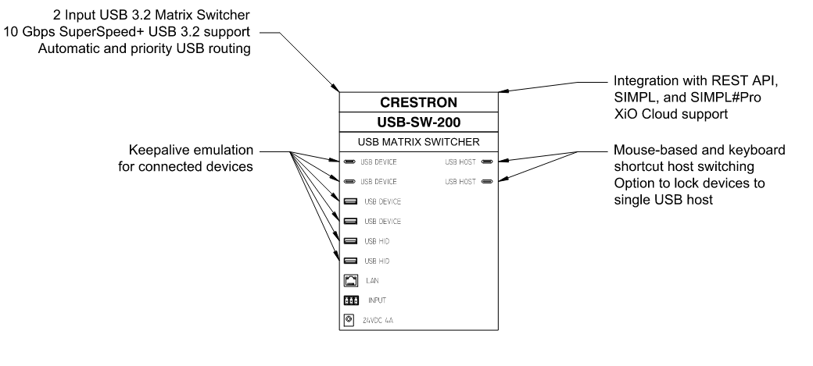

USB-SW-400
