SECTION 27 41 16
INTEGRATED AUDIO-VIDEO SYSTEMS AND EQUIPMENT

GUIDE SPECIFICATION

Specifier: The Specifier/Design Professional is responsible for the accuracy of all project specifications, including system application and coordination with related sections. This guide specification is provided as a convenience and requires editing to match actual project requirements. CRESTRON ELECTRONICS, INC. SHALL NOT BE LIABLE FOR ANY DAMAGES ARISING OUT OF THE USE OF ANY OF ITS GUIDE SPECIFICATIONS. For Crestron design assistance and design review please contact Sales Support Services Department at 800.237.2041 or techsales@crestron.com.

Specifier: Please see PART 4 for a listing of products specified in this Guide Specification.

Table of Contents
1 GENERAL 3
2 PRODUCTS 3
2.1 USB over Network with Routing, Local / Remote Pair 3
2.1.1 Basis of Design 3
2.1.2 Device Definition 3
2.1.3 Device Architecture 4
2.1.4 Connectors 4
2.1.5 Controls and Indicators 5
2.1.6 Power 6
2.1.7 Compliance 6
2.2 USB over Network Wall Plates with Routing, Local / Remote Pair 6
2.2.1 Basis of Design 6
2.2.2 Device Definition 7
2.2.3 Device Architecture 7
2.2.4 Connectors 8
2.2.5 Controls and Indicators 9
2.2.6 Power 10
2.2.7 Compliance 10
3 EXECUTION 10
4 APPENDICES 10
4.1 SPECIFIED PRODUCTS 10
4.1.1 Crestron DM-NUX-L2 10
4.1.2 Crestron DM-NUX-R2 10
4.1.3 Crestron DM-NUX-L2-1G 11
4.1.4 Crestron DM-NUX-R2-1G 11
4.2 Input / Output Connection Diagrams 11
4.2.1 DM-NUX-L2 11
4.2.2 DM-NUX-R2 11
4.2.3 DM-NUX-L2-1G 11
4.2.4 DM-NUX-R2-1G 11

GENERAL
NOT USED in this Guide Specification. Specifier shall Specify PART 1 administrative and procedural requirements as needed.

PRODUCTS

USB over Network with Routing, Local / Remote Pair

Specifier Note:
The DM NUX USB over Network with Routing (DM-NUX-L2 and DM-NUX-R2) deliver reliable, high-speed USB signal extension and routing for USB 1.0, 1.1, and 2.0 devices throughout a home, business, or campus for distances up to 300 ft. (100 m).

Basis of Design

Crestron DM-NUX-L2

Crestron DM-NUX-R2

Device Definition

Devices with the following characteristics:

High-speed USB signal extension for most USB 1.1 or 2.0 devices

Point-to-point USB signal extension support

USB signal extension over Ethernet support

Compatibility with wall plate form-factor USB over Network with Routing devices by same manufacturer

Compatibility with AVoIP endpoints by same manufacturer that support USB 2.0 signal extension

Compatibility with proprietary HDBaseT-based AV system by same manufacturer

Specifier Note:
All USB endpoints must be on the same layer 2 domain as the control system or DigitalMedia system. Follow accepted guidelines for proper installation and configuration of the local area network to ensure optimum performance.

Local endpoint Virtual Hub support of up to (5) remote endpoints

Signal routing via control system or proprietary AV system by same manufacturer

Plug-and-play compatibility with most types of USB 1.1 and 2.0 devices and hosts

No drivers required with Windows®, macOS®, or Linux® operating systems

USB over Ethernet or CAT5e (or better) data transfer rate of up to 480 Mbps

Mass Storage Acceleration maximizes USB 2.0 bulk transfer rates

Device Architecture

Enclosure

Construction: Black anodized aluminum

Mounting: Freestanding or surface mount (mounting bracket included)

Dimensions

Height: 1.02 in. (26 mm)

Width: 3.94 in. (100 mm)

Depth: 2.99 in. (76 mm)

Environmental Operating Conditions

Temperature: 32° to 122° F (0° to 50° C)

Humidity: 20% to 80% RH (non-condensing)

Connectors

Local Endpoint

Link

(1) 8-pin RJ45 connector, female

Connects to an Ethernet network or directly to a Remote endpoint

Specifier Note:
For a direct link connection (not on a network) between the Local and Remote endpoints, use high quality, solid core CAT5e (or better) unshielded twisted pair (UTP) cable. To comply with the European Directive (CE), Crestron recommends using high-quality, solid core CAT5E (or better) shielded twisted pair (STP) cable. If connecting either endpoint through a wall jack, a stranded patch cord may be used. The maximum aggregate cable length is 330 ft (100 m) between units. The minimum cable length is 6 ft (1.8 m)

USB

(1) USB Type B connector, female

USB B to A cable included

USB 2.0 device port for connection to the USB host computer, media server, game console, annotator, codec, etc.

Config: For factory use only

Remote Endpoint

24V 1A

(1) 2.1 x 5.5 mm DC power connector; 24 VDC power input

Power pack included

Link

(1) 8-pin RJ45 connector, female

Connects to an Ethernet network or to the Link port on the Local endpoint

Specifier Note:
For a direct link connection (not on a network) between the Local and Remote endpoints, use high quality, solid core CAT5e (or better) unshielded twisted pair (UTP) cable. To comply with the European Directive (CE), Crestron recommends using high-quality, solid core CAT5E (or better) shielded twisted pair (STP) cable. If connecting either endpoint through a wall jack, a stranded patch cord may be used. The maximum aggregate cable length is 330 ft (100 m) between units. The minimum cable length is 6 ft (1.8 m)

USB

(4) USB Type A connectors, female

USB 2.0 host ports for connection of USB devices such as mice, keyboards, and other USB devices

Available USB power: Up to 600 mA at each port concurrently; up to 1 A when two or fewer ports are in use

Specifier Note:
A web camera may not be used when five or more DM-NUX-R2 endpoints are paired. Video from two cameras connected to a DM-NUX-R2 may not be viewed on different applications simultaneously. Any 1.0/1.1 devices require a USB hub.

Config: For factory use only

Controls and Indicators

Local Endpoint

Activity: (1) Amber LED, indicates data activity over the Link connection

Host: (1) Green LED, indicates a valid connection to the USB host

Link: (1) Green LED, indicates a valid Link connection to the Remote endpoint

Pair: (1) Pushbutton, used to establish a connection with a Remote endpoint

Power: (1) Blue LED, indicates operating power is supplied via the USB host

Remote Endpoint

Activity: (1) Amber LED, indicates data activity over the Link connection

Host: (1) Green LED, indicates a valid connection to the USB host at the Local endpoint

Link: (1) Green LED, indicates a valid Link connection to the Local endpoint

Pair: (1) Pushbutton, used to establish a connection with a Local endpoint

Power: (1) Blue LED, indicates operating power is supplied via the power supply

Power

Local Endpoint: USB powered via the USB host interface

Remote Endpoint

Input: 100-240 VAC, 50/60 Hz

Output: 0.75 A @ 24 VDC

Compliance

Regulatory Model: M201947001

CE, IC, FCC Part 15 Class B digital device

USB over Network Wall Plates with Routing, Local / Remote Pair

Specifier Note:
The DM NUX USB over Network with Routing (DM-NUX-L2 and DM-NUX-R2) deliver reliable, high-speed USB signal extension and routing for USB 1.0, 1.1, and 2.0 devices throughout a home, business, or campus for distances up to 300 ft. (100 m).

Basis of Design

Crestron DM-NUX-L2-1G

Crestron DM-NUX-R2-1G

Device Definition

Devices with the following characteristics:

High-speed USB signal extension for most USB 1.1 or 2.0 devices

Point-to-point USB signal extension support

USB signal extension over Ethernet support

Compatibility with USB over Network Extenders with Routing by same manufacturer

Compatibility with proprietary HDBaseT-based AV system by same manufacturer

Specifier Note:
All USB endpoints must be on the same layer 2 domain as the control system or DigitalMedia system. Follow accepted guidelines for proper installation and configuration of the local area network to ensure optimum performance.

Local endpoint Virtual Hub support of up to (5) remote endpoints

Signal routing via control system or proprietary AV system by same manufacturer

Plug-and-play compatibility with most types of USB 1.1 and 2.0 devices and hosts

No drivers required with Windows®, macOS®, or Linux® operating systems

USB over Ethernet or CAT5e (or better) data transfer rate of up to 480 Mbps

Mass Storage Acceleration maximizes USB 2.0 bulk transfer rates

Device Architecture

Enclosure

Construction: Metal, black finish with white or black polycarbonate label overlay

Flush Wall Mount: Mounts in an unobstructed North American 1-gang electrical box

To be used in conjunction with decorator style faceplate by same manufacturer

Dimensions

Height: 4.12 in. (105 mm)

Width: 1.72 in. (44 mm)

Depth: 1.95 in. (50 mm)

Environmental Operating Conditions

Temperature: 32° to 122° F (0° to 50° C)

Humidity: 20% to 80% RH (non-condensing)

Connectors

Local Endpoint

24 V 0.75 A

(1) 2-pin 3.5 mm detachable terminal block

24 VDC power input

Specifier Note:
A ferrite bead is provided to reduce or prevent EMI (electromagnetic interference). When using a power source other than PoE, Crestron recommends installing this ferrite bead on the power supply cable close to the device.

LINK

(1) 8-pin RJ45 connector, female

Connects to an Ethernet network or directly to a Remote endpoint

IEEE 802.3af

Specifier Note:
For a direct link connection (not on a network) between the Local and Remote endpoints, as a minimum, use high quality, solid core CAT5e (or better) unshielded twisted pair (UTP) cable. To comply with the European Directive (CE), Crestron recommends using high-quality solid core CAT5e (or better) shielded twisted pair (STP) cable. If connecting either endpoint through a wall jack, a stranded patch cord may be used. The maximum aggregate cable length is 330 ft (100 m) between units. The minimum cable length is 6 ft (1.8 m). Do not connect the LINK ports to any other USB extender, including the USB-EXT-2, USB-EXT-2-LOCAL-1G, and USB-EXT-2-REMOTE-1G.

USB

(1) USB Type B connector, female

USB 2.0 device port for connection to the USB host computer, media server, game console, annotator, codec, etc.

CONFIG: For factory use only

Remote Endpoint

24 V 0.75 A

(1) 2-pin 3.5 mm detachable terminal block

24 VDC power input

LINK

(1) 8-pin RJ45 connector, female

Connects to an Ethernet network or to the Link port on the Local endpoint

Specifier Note:
For a direct link connection (not on a network) between the Local and Remote endpoints, use high quality, solid core CAT5e (or better) unshielded twisted pair (UTP) cable. To comply with the European Directive (CE), Crestron recommends using high-quality, solid core CAT5E (or better) shielded twisted pair (STP) cable. If connecting either endpoint through a wall jack, a stranded patch cord may be used. The maximum aggregate cable length is 330 ft (100 m) between units. The minimum cable length is 6 ft (1.8 m)

IEEE 802.3af

USB

(4) USB Type A connectors, female

USB 2.0 host ports for connection of USB devices such as mice, keyboards, and other USB devices

CONFIG: For factory use only

Controls and Indicators

Local Endpoint

ACT: (1) Amber LED, indicates data activity over the LINK connection

HOST: (1) Green LED, indicates a valid connection to the USB host

LINK: (1) Green LED, indicates a valid LINK connection to the Remote endpoint

PAIR: (1) Pushbutton, used to establish a connection with a Remote endpoint

PWR: (1) Blue LED, indicates operating power is supplied via the USB host

Remote Endpoint

ACT: (1) Amber LED, indicates data activity over the LINK connection

HOST: (1) Green LED, indicates a valid connection to the USB host at the Local endpoint

LINK: (1) Green LED, indicates a valid LINK connection to the Local endpoint

PAIR: (1) Pushbutton, used to establish a connection with a Local endpoint

PWR: (1) Blue LED, indicates operating power is supplied via the power supply

Power

Local Endpoint

USB powered via the USB host interface

IEEE 802.3af powered device

Optional ferrite bead provided to reduce or prevent EMI (electromagnetic interference)

Remote Endpoint

Input: 100-240 VAC, 50/60 Hz

Output: 0.75 A @ 24 VDC

Compliance

IC, FCC Part 15 Class B digital device

EXECUTION
NOT USED in this Guide Specification. Specifier shall Specify PART 3 On-Site work as needed.

APPENDICES

SPECIFIED PRODUCTS
Specifier Note: This Article includes Crestron products specified in this Guide Specification document. This Article is for reference only and should not be required in actual project manual unless included in an overall system equipment list.

Crestron DM-NUX-L2

Crestron DM-NUX-R2

Crestron DM-NUX-L2-1G

Crestron DM-NUX-R2-1G

Input / Output Connection Diagrams

DM-NUX-L2
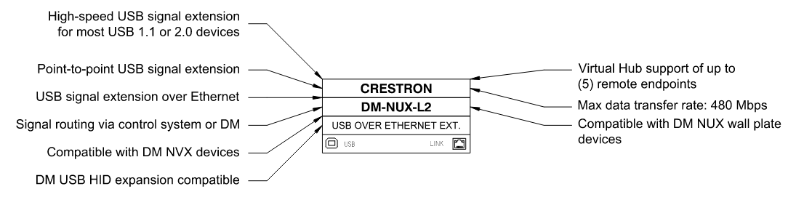

DM-NUX-R2
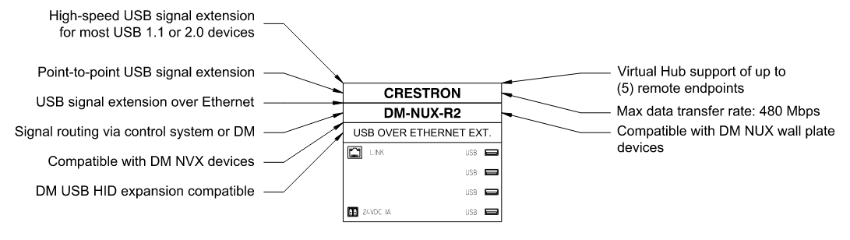

DM-NUX-L2-1G
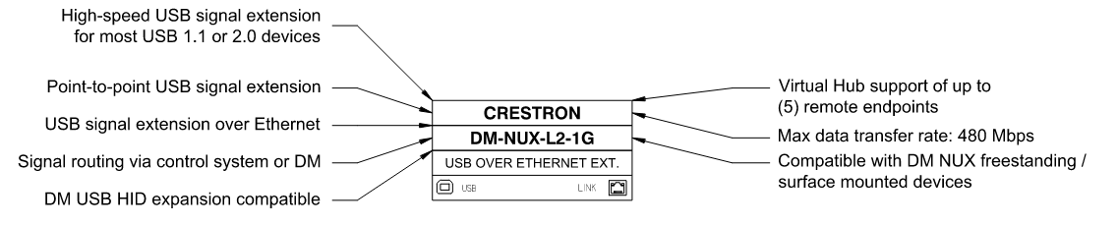

DM-NUX-R2-1G
